**Laboratory 04 – Filter Design using MATLAB**

1. Design the Butterworth filter with the following specifications: Fp = 1000 Hz; Fs = 5000 Hz;

clear all;

close all;

Fp=1000;

Fs=5000;

Fsample=10000;

Wp=Fp/Fsample;

Ws=Fs/Fsample;

[N,Wn]=buttord(Wp,Ws,3,30);

[zeros_,poles_,scale_]=butter(N,Wn);

[num,den]=butter(N,Wn);

tf=zpk(zeros_,poles_,scale_);

figure

freqz(num,den,5000,Fsample)

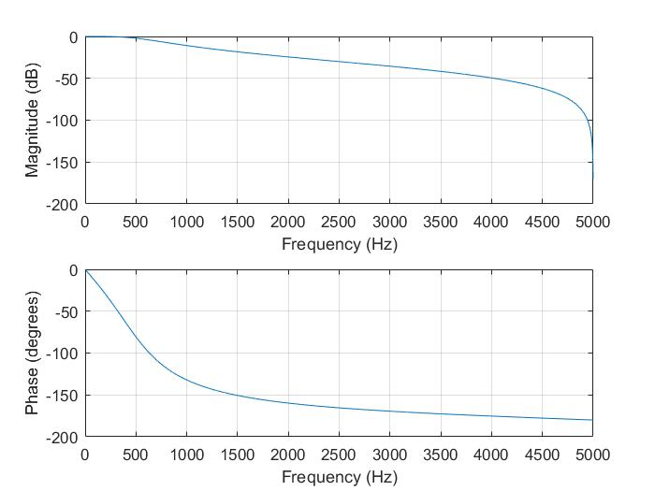

1. Design the Butterworth filter with Fp = 1000 Hz, N = 4;

clear all;

close all;

N=4;

Fp=1000;

Wp=2*pi*Fp;

[num,den]=butter(N,Wp,'s');

fil=tf(num,den);

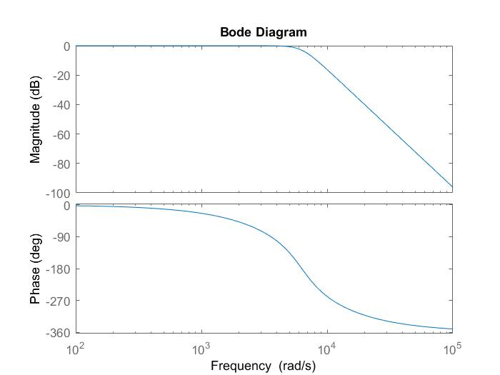bode(fil);

1. Design Chebyshev Type 1 filter with N = 4, Rp = 2 ; Fp = 1000.

clear all;

close all;

N=4;

Rp=2;

fp=1000;

Wp=2*pi*fp;

[num,den]=cheby1(N,Rp,Wp,'s');

fil=tf(num,den);

bode(fil);

